Training for Fast Contract templates for expedited processing

Use of the fast contract templates for expedited processing is intended for low-risk purchases that need a Statement of Work, do not include a vendor’s terms and conditions or require signature. If changes or a different contract template is needed, the UNTS Office of Contract Administration can help you determine which contract template to use.

# Services Statement of Work (SOW)



|  |  |
| --- | --- |
| This QUICK template is intended for the procurement of SERVICES.   * The SOW Quick template accompanies the UNT System Purchase Order (PO) * It is not intended as a “stand alone” document * The SOW template is for use “as is” – no revisions permitted to the template   + If changes are needed, use a different contract template.     - The UNTS Office of Contract Administration can help you determine which contract template to use. |  |

|  |  |
| --- | --- |
| This QUICK template is **NOT** intended for   * IT Related contracts/agreements * Contract/Agreements that require revisions to this template * Prepayments required by the vendor * *\*Consult your campus Office of Sponsored Research office before use* |  |

### Determining if your contract is IT related

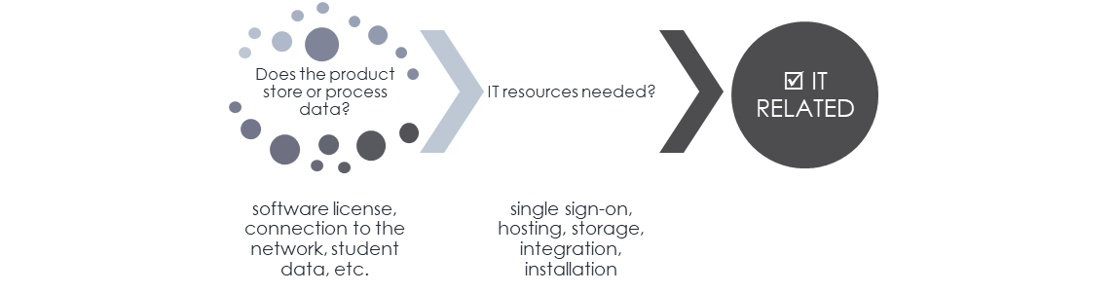

|  |  |
| --- | --- |
|  | Services Statement of Work (SOW) contract QUICK template is utilized as is – no revisions. If changes are needed, use a different contract template. The UNTS Office of Contract Administration can help you determine which contract template to use. |

This QUICK template is intended for the procurement of SERVICES.

* The SOW Quick template accompanies the UNT System Purchase Order (PO)
* It is not intended as a “stand alone” document
* The SOW template is for use “as is” – no revisions permitted to the template
* *Not to be used if the vendor requires prepayment*
  + If changes are needed, use a different contract template.
    - The UNTS Office of Contract Administration can help you determine which contract template to use.

# How to use the SOW Quick Template

* Download the Services SOW template from the [Procurement](https://finance.untsystem.edu/procurement/index.php) or [UNTS Office of Contract Administration](https://finance.untsystem.edu/contract-administration/training-and-resources-oca.php) websites.
* You or your vendor can fill in the requested information (or copy and paste from the vendor’s proposal/quote)

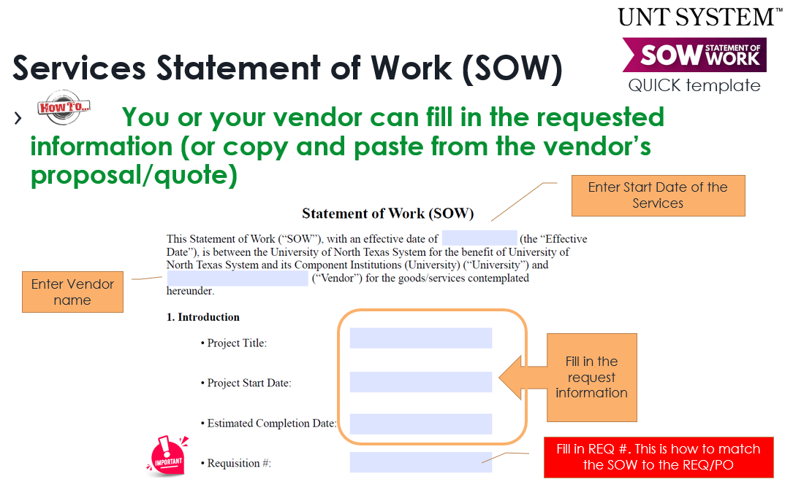

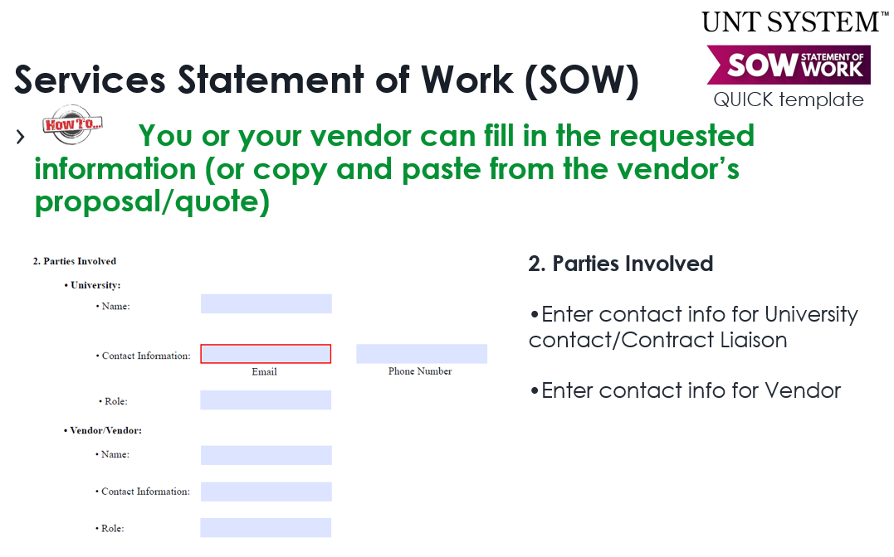

University contact/Contract Liaison is the individual in the department most knowledgeable about the Services who can answer questions.

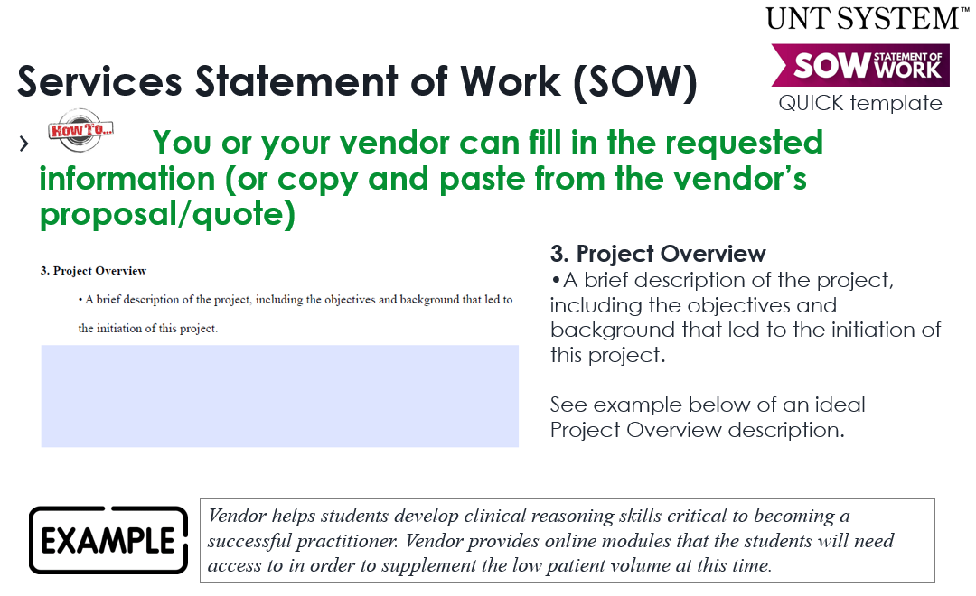

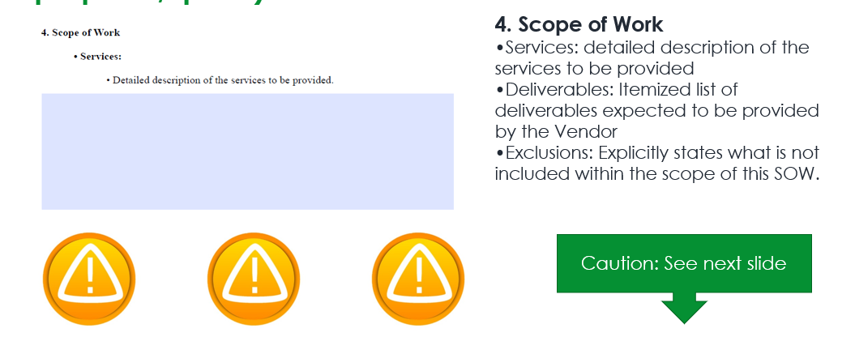

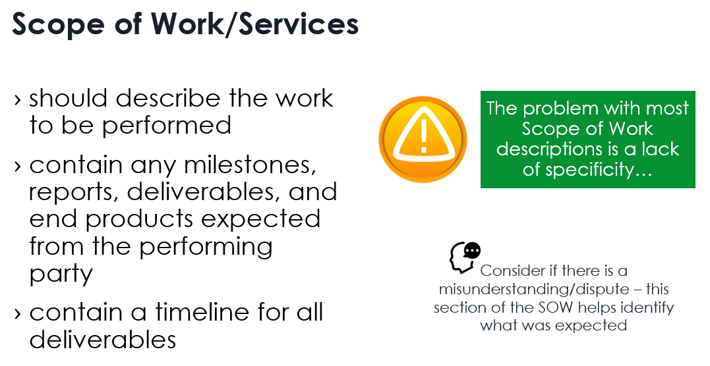

|  |  |
| --- | --- |
| **Scope of Work/Services OBJECTIVES Examples** | |
| **Statement** | *Assess class needs for public health awareness. Write curriculum to address needs.* |
|  | *The problem with the above example is that nothing is specified. The task should have a measurable in it and the deliverable must be quantifiable.* |
|  | *Survey 4 classes of 20 students in asthma awareness. Each class will answer a 25-question survey that assesses their general knowledge of asthma issues as they relate to public health. One reviewer should take about 1 hour with each class to take the survey and another 2 hours per class to assess the data. A 10-hour curriculum for graduate student classes of up to 20 students that addresses issues of deficiencies in public health awareness in asthma prevention and care.* |

|  |  |
| --- | --- |
| **Scope of Work/Services Soft deliverables Examples** | |
| **Statement** | *Contractor will be required to give weekly reports of progress during the soy bean season with more frequent reports during the height of the season.* |
|  | *The problem with the above example is that it does not specify what needs to be in the reports, what “more frequent” means, and when the “height of the season” is.* |
|  | *Contractor will be required to give weekly reports consisting of: wind pattern analysis, fungi spore distribution, and potential risk areas. During the height of the season, May 15-July 15, the Contractor may be required to give twice-weekly reports.* |

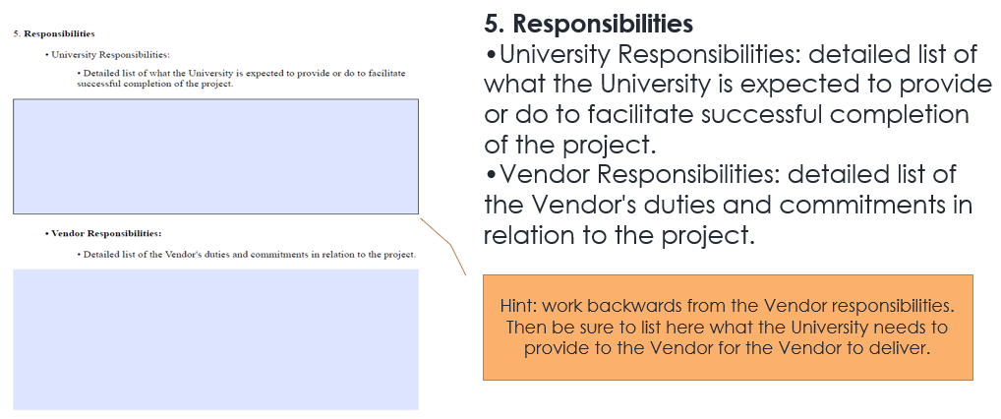

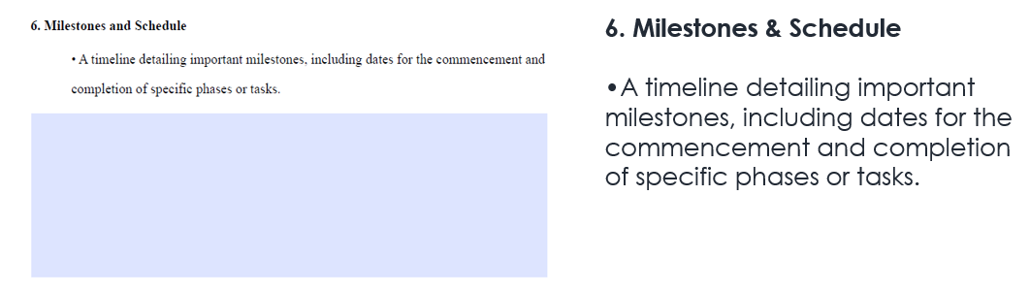

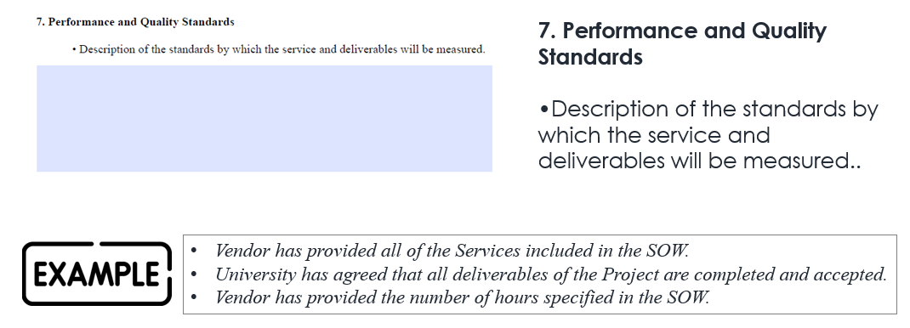

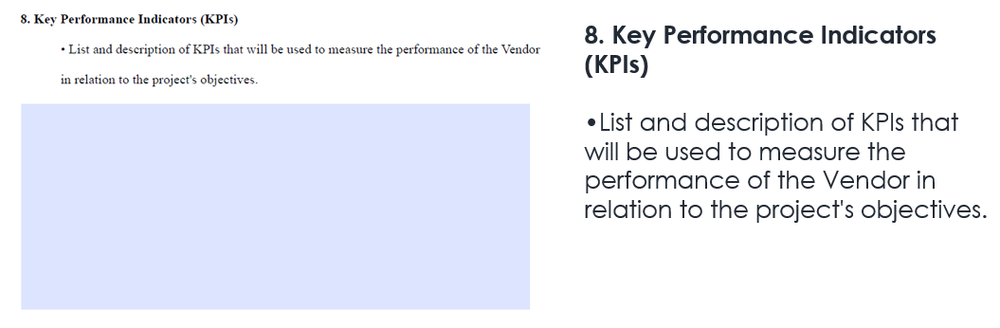

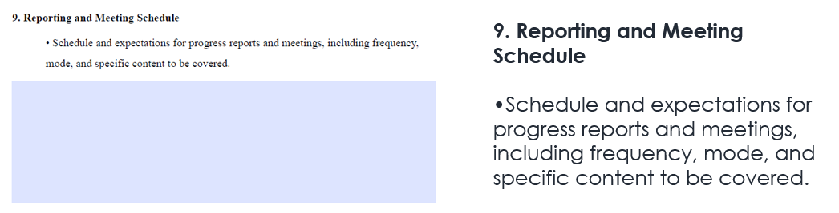

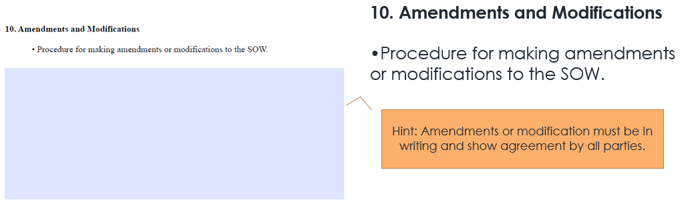

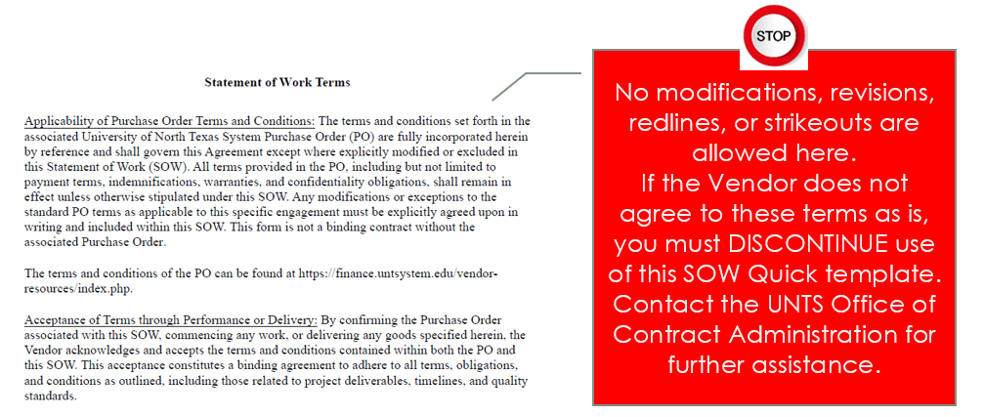

* Attach the completed template to your E-PRO requisition

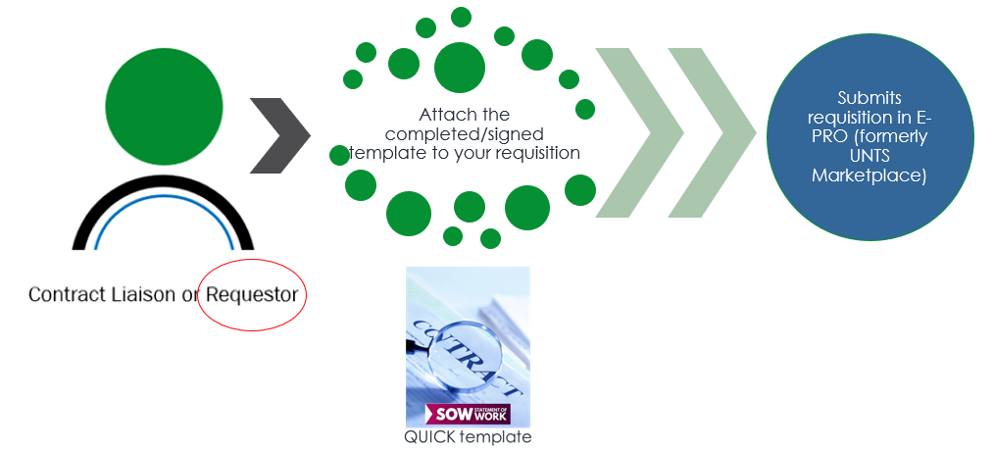

* + Once the requisition approvals have been completed, the SOW quick template contract is considered executed and the Purchase Order will be generated/dispatched.

# Guest Speaker Quick Template



|  |  |
| --- | --- |
| This QUICK template is intended for the procurement of SERVICES for a speaker.   * The Guest Speaker template accompanies the UNT System Purchase Order (PO) * It is not intended as a “stand alone” document * The SOW template is for use “as is” – no revisions permitted to the template   + If changes are needed, use a different contract template.     - The UNTS Office of Contract Administration can help you determine which contract template to use. |  |
| ***Is a contract for a speaker or presenter required?*** | |
| No, a contract for a speaker is not *required*. You have the option to use the [Payment Request](https://finance.untsystem.edu/procurement/epro/documents/training/guide-to-payment-request-form-u2.pdf) which does not require a contract document and is a prompt payment option.  To determine use of a contract, consider:   * Elements of the speaking engagement/presentation that are important to agree to and/or document in advance (i.e. recording the session, use of photographs, reuse of presentation materials, etc.) | |

|  |  |
| --- | --- |
| This QUICK template is **NOT** intended for   * Contract/Agreements that require revisions to the template * Contract/Agreements that require signature of University signatories |  |

# How to use the Guest Speaker Quick Template

* Download the Guest Speaker Quick Template from the [Procurement](https://finance.untsystem.edu/procurement/index.php) or [UNTS Office of Contract Administration](https://finance.untsystem.edu/contract-administration/training-and-resources-oca.php) websites
* Fill in the check boxes, and blanks as applicable

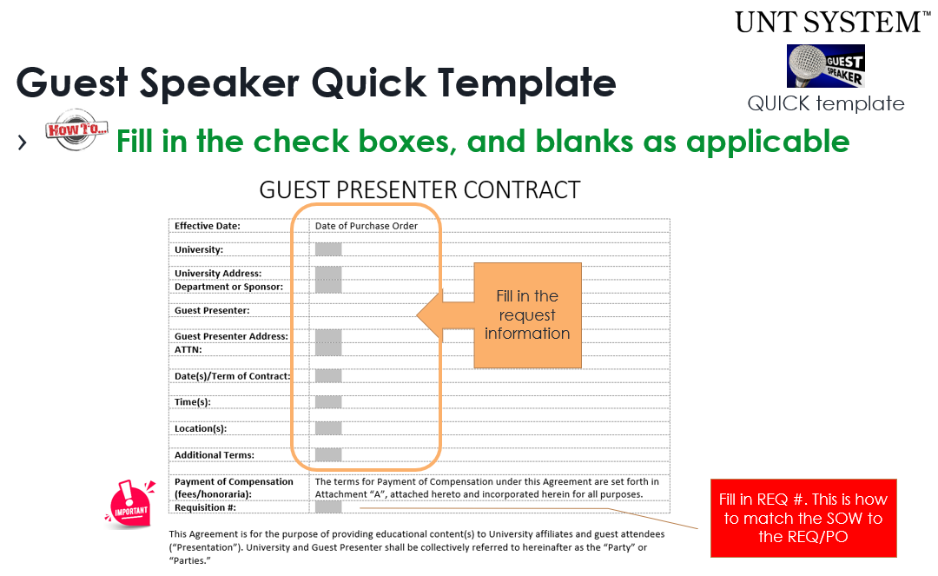

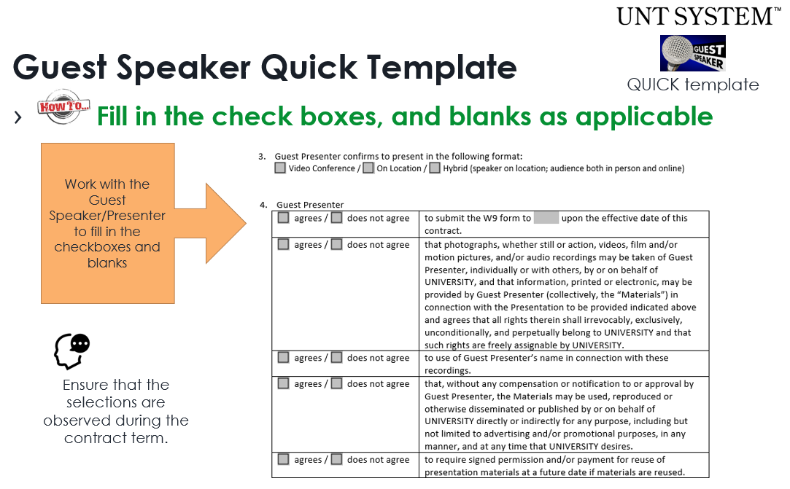

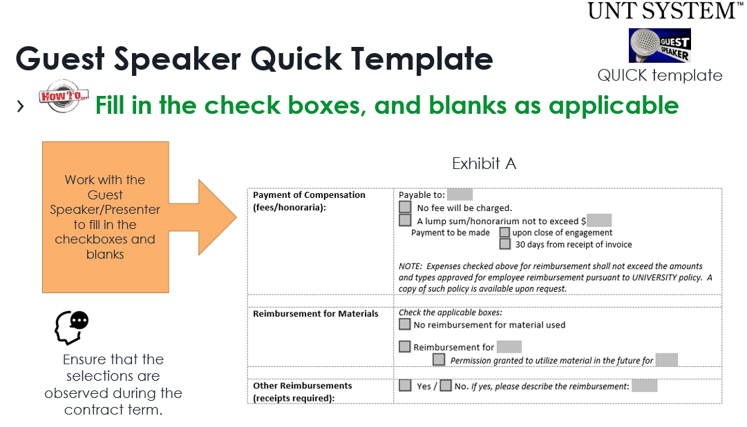

* Send to the Guest Speaker/Presenter to sign the contract

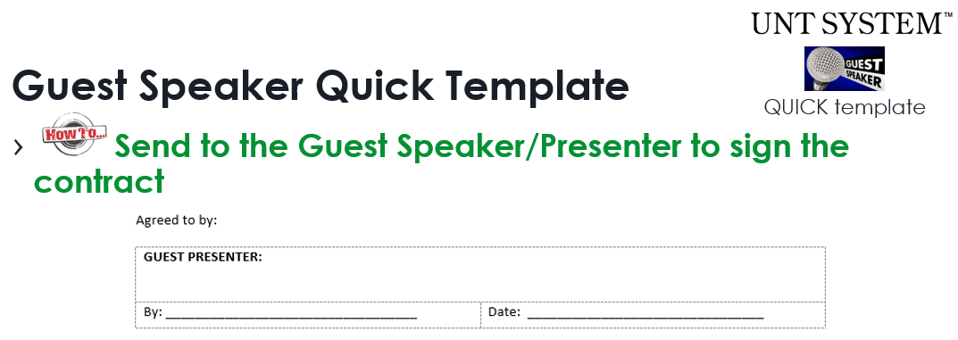

* Attach the completed/signed template to your E-PRO requisition

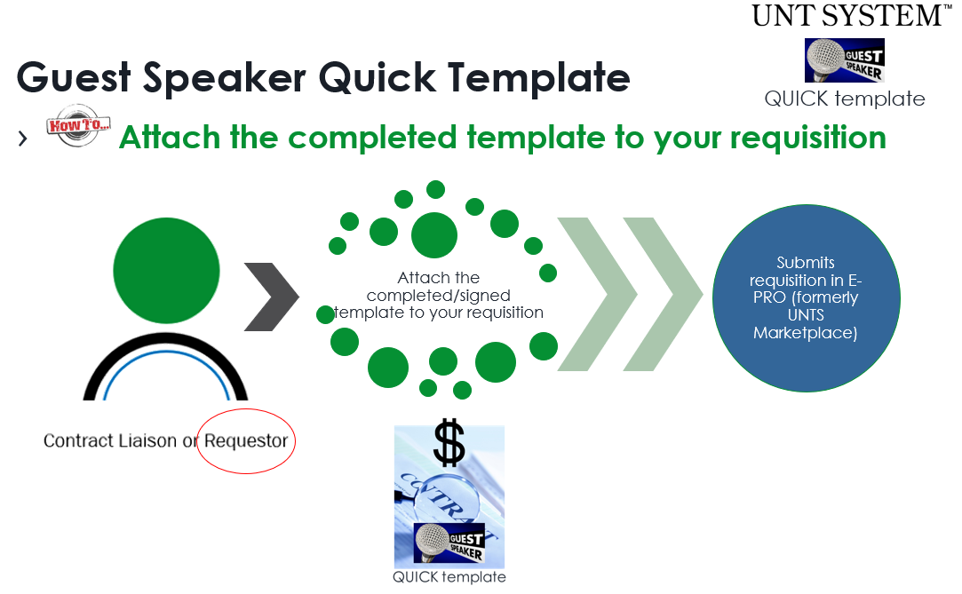

* + Once the requisition approvals have been completed, the Guest Speaker quick template contract is considered executed and the Purchase Order will be generated/dispatched

# Questions/Resource



UNTS Office of Contract Administration (OCA)

Department Email: [UNTScontractadmin@untsystem.edu](mailto:UNTScontractadmin@untsystem.edu)

HSC External webpage: <https://www.unthsc.edu/division-of-finance/contract-administration/>

HSC Internal webpage: <https://myunt.sharepoint.com/sites/HSCFinanceWebsite/SitePages/Total-Contract-Manager-(TCM).aspx>

UNTS OCA webpage: <https://finance.untsystem.edu/contract-administration/index.php>