Training for Contract Liaisons for transitioning from PCARD to requisition

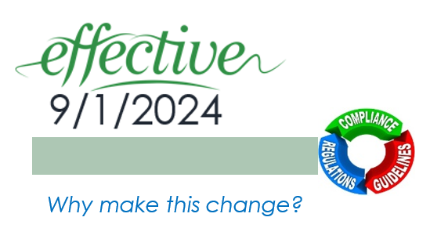 

*If you attended one of the “live” Q&A sessions, please be aware that this version of the PowerPoint/handout includes updates to the process and some of the questions asked/answered in the sessions.*

# LoadingAGENDA

* Areas Involved in process change
* FY2025 Change – contracts transitioned to Requisitions
* Questions & Answers
* Process Reviews

# Areas Involved in process change



|  |  |
| --- | --- |
|  | Department Requestor/Contract Liaison   * will submit the appropriate Procurement Method (PCARD or requisition) * Initiate/manage business contracts |
|  | UNTS Purchasing is responsible for compliance with established purchasing guidelines, Texas procurement requirements, and Requisition-to-Purchase Order Processing. [Buyers@untsystem.edu](mailto:Buyers@untsystem.edu) |
|  | UNTS Office of Contract Administration facilitates business contract processing, routing and administration. [UNTScontractadmin@untsystem.edu](mailto:UNTScontractadmin@untsystem.edu) |
|  | The UNTS PCARD team oversees the PCARD program help simplify small dollar purchasing needs under the Texas Comptroller of Public Accounts for the State of Texas contract. [PCard@untsystem.edu](mailto:PCard@untsystem.edu) |
|  | The Vendor/external party/2nd Party/Contract Organization enters into business contracts with UNIVERSITY and makes them enforceable obligations of both parties. |

# FY 2025 changes



Effective 9/1/2024 payment for certain contracts must start with a requisition (not PCARD payments).

There are exceptions. The following contracts/agreements are approved for PCARD payments…

|  |  |
| --- | --- |
|  |  |
| Copier/Printers, Food/Catering, Conference Registrations, Event Rental, Hotel contracts (Athletics & Events). | VENDORS: Cintas, Charter, EJs towing, Unifirst, Directv, Aramark |
| NOTE: Follow travel guide for individual Hotel travel. [Travel (untsystem.edu)](https://finance.untsystem.edu/travel/index.php) |  |

## DISCLAIMERS

For the agreements/contracts that contain Terms and Conditions and/or signature and are permitted to be paid with a **PCARD** (instead of a Purchase Order).

* **Compliance with the Purchasing Card Guide is still required.**
  + **Any PCARD exception and/or vendor hold search must still be completed.** See note about vendor hold search below.
    - **The PCARD exception process is NOT intended for requesting approval for *payment* by PCARD.**

All other contract category types must transition to the requisition process.

**IT related contracts for which the payment mechanism has been a PCARD must be transitioned to the requisition process effective 9/1/2024.**

NOTE: If applicable, before submitting a PCARD & CLICKWRAP agreements, ensure that you have acquired IT Compliance approval so that you can upload the approval documentation to your request. IT approval can be acquired by submitting a Technical Acquisition Questionnaire (TAQ) that is available within ServiceNow. The TAQ must now be completed, and an IT Compliance Release obtained prior to submission of the requisition & routing of the contract. The link to the TAQ is available at the System IT, Acquisition of Technology Resources page: <https://itss.untsystem.edu/divisions/mrs/it-compliance/technology-risk-assessment-program.php>.

### Determining if your contract is IT related

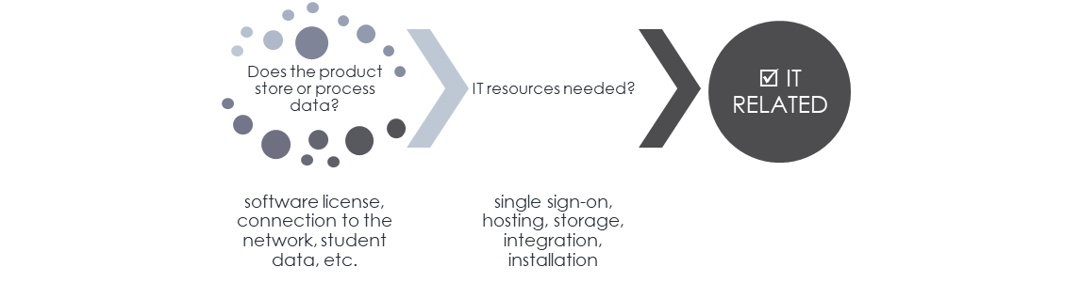 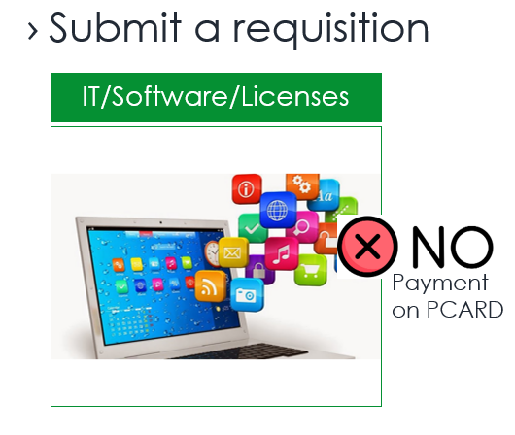

Vendors must complete [PaymentWorks](https://www.paymentworks.com/login/saml/?idp=unt) registration in E-PRO (formerly UNTS Marketplace) to receive payment by Purchase Order. Departments can send PaymentWorks registration invitations directly to vendors to initiate the process.

|  |  |
| --- | --- |
|  |  |

|  |
| --- |
| If these roles are performed by separate individuals in your department, ensure adequate internal communication to avoid the possibility of double-payments. |

# Questions & Answers



* Does this change (paying with a Purchase Order instead of a PCARD) include CLICKWRAP AGREEMENTS?

*ClickWrap agreements are used in internet purchases where the person making the purchase is required to click "I Agree" to the vendor’s terms and conditions.*

* + *Yes, this change includes* ***IT related*** *CLICKWRAP agreements. IT related CLICKWRAP contracts/agreements will need to transition to the requisition process.*
  + *Other Clickwrap agreements can remain on PCARD.*
* What if the vendor won’t accept the Purchase Order (PO) and the contract is not in one of the “approved” contract category types to remain on PCARD?

*You know at the beginning of the process (website notice or email) that the vendor does not accept POs*

* + *The Contract Liaison can submit the contract via a Contract Request in TCM. The submission needs to include:*
    - *The notice from the vendor (can be an email, print out from a website or a screenshot from the website) as an Attachment*
    - *Note in the Summary or Special Instructions field about the PCARD payment request*
* *What if the vendor rejects the Purchase Order terms and conditions? Example: the contract was executed, PO was sent to the vendor.*
  + *If the vendor rejects the Purchase Order in writing, alert your Buyer via email (*[*buyers@untsystem.edu*](mailto:buyers@untsystem.edu)*) and include the email correspondence from the vendor that contains their explanation for rejecting the PO or the vendor’s redlined changes. The Buyer will submit the request to the Contracts team on your behalf.*
    - *\*\*For HSC Campus: during FY 25 the two TCM modules will be merged. You will be alerted when contract submissions will be in E-PRO submitted on your behalf. Until you’re notified, continue the current process (HSC TCM).*
* Both the Requestor and the Contract Liaison processed the contract so we accidently paid twice – 1) by PCARD and 2) by Purchase Order. What do we do?
  + *You will need to contact your vendor to request a refund. The preferred method is to request a refund on the PCARD. Reach out to the Buyers via email (*[*buyers@untsystem.edu*](mailto:buyers@untsystem.edu)*) if the vendor requests a different method to refund the overpayment.*
* For the vendor hold search (VHS): what do we do if we have a purchase over $500 in the coming days. [The Vendor Hold Search Tool was discontinued effective 8/15/2024].
  + Attach a screenshot of the announcement in place of the VHS results. Once a new process has been developed, we will make another announcement and send out a mass email.
  + Link: [https://finance.untsystem.edu/procurement/p-card-program/vendor-hold-search-resources.php#:~:text=ANNOUNCEMENT,requests%20and%20reports.***](https://finance.untsystem.edu/procurement/p-card-program/vendor-hold-search-resources.php)
* 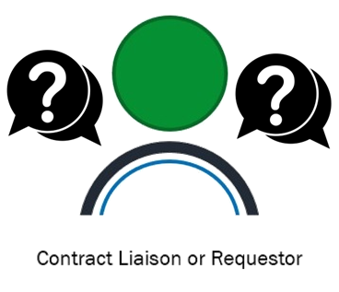Event Rentals: does this include companies that set up exhibitor booths, display boards, etc. for events at hotels? Can this type of payment still go on a PCARD?
  + Yes, this contract category type includes vendors that set up exhibitor booths & display boards on campus for events.
  + Yes, this type of payment can still be made by PCARD.
* In the past it was mentioned that anything/service or goods' invoices indicates terms and conditions - it is considered a contract and must be submitted to contracts. Is this still the situation? Do we submit through requisition?
  + Contract/agreements/quotes/invoices/proposals that contain terms and conditions (either listed on the document or indicated in a website reference) and/or require signatures are considered contracts.
  + Follow the appropriate submission process, either : 1) requisition process (attach contract) or 2) submit contract to the Contracts team via a Contract Request.
* Can a contract for professional coaching be paid via PCARD?
  + A contract for professional coaching will need to transition to the requisition process.
  + If the professional coaching entity will not accept payment by Purchase Order, the Contract Liaison will need to attach the appropriate documentation with the contract submission (can be an email from the vendor, print out from a website or a screenshot from the website).
* If there is no contract we do not have to transition to a requisition?
  + If there is not contract (a quote ONLY which does not contain terms & conditions or a requirement for signature) then you may use the payment method you are currently using.
  + This FY25 change is focused on the payment method for contracts and agreements.
* Do we need to attach a contract for continuing services on requisitions to transition payment from PCARD to PO? [Background: department has an executed contract they have been paying by PCARD and are transitioning the payment method to requisition.]
  + The answer is yes - you will attach the appropriately executed contract to the requisition. (A contract that is signed by an individual with appropriate authority to sign).
* Will Procurement continue to review which contract categories can be approved for PCARD payments?
  + *Yes, Procurement will periodically review and provide updates via the website:* [*https://finance.untsystem.edu/contract-administration/click-wrap-approval.php*](https://finance.untsystem.edu/contract-administration/click-wrap-approval.php)*.*

# Process Review



|  |  |
| --- | --- |
|  |  |
|  |  |
|  |  |
|  |  |

# Questions/Resource



Visit the PCARD/Clickwrap approval website

<https://finance.untsystem.edu/contract-administration/click-wrap-approval.php>