Instructions for Entering Service Now Requests and Issue/Error Reporting for Financial System Support (FSS) & Access Control Executive (ACE)

Service Now is the application used to capture technical and/or functional requests from business units. Service Now Requests can now be utilized for the Financial System Support (FSS) and Access Control Executive (ACE) team for;
- FS Security Requests – Add, Modify or Remove FS EIS, Oracle / Golden, Perceptive Content, USAS and Cognos security.
- FS Service Requests - For all other items which are not requests for security or help resolving an issue, such as requests for setups/configurations assistance in EIS Financials environments.
- FS Error and Incidents – Report errors and incidents for FS EIS environments.

Service Now can be accessed by several different methods. Your EUID and password are required login credentials.
- Access via website address
http://web3.unt.edu/helpdesk/service

- Access via the icon on your desktop
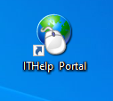

- Access via hyperlink on FSPD homepage
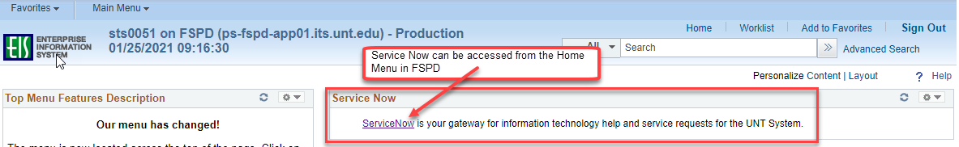

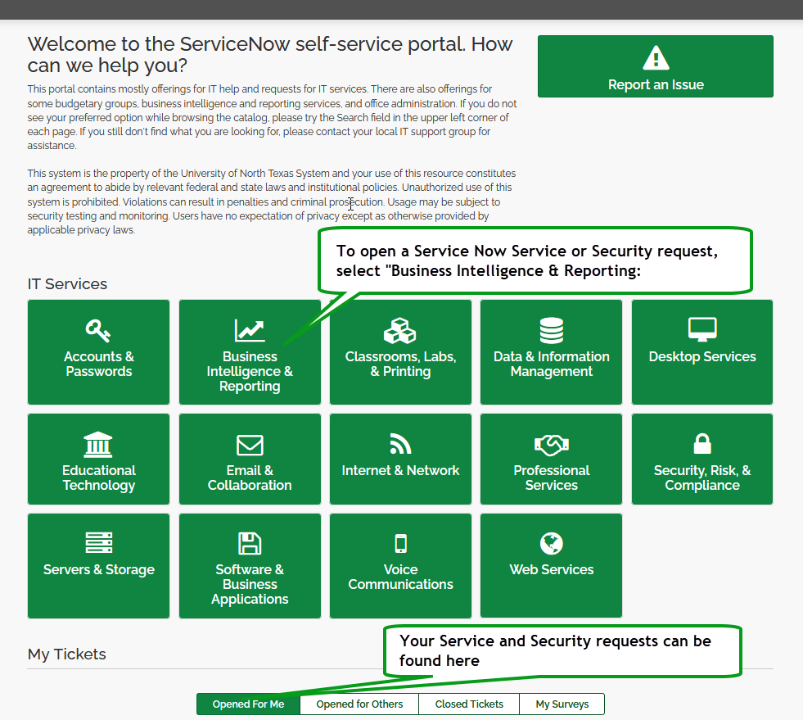

For security or service requests select the “Financial Systems Support (FSS) and Access Control Executive (ACE) Request” tile, and to report an issue or error select the “Issue/Error with Financial Systems Support (FSS) or Access Control Executive (ACE)”:

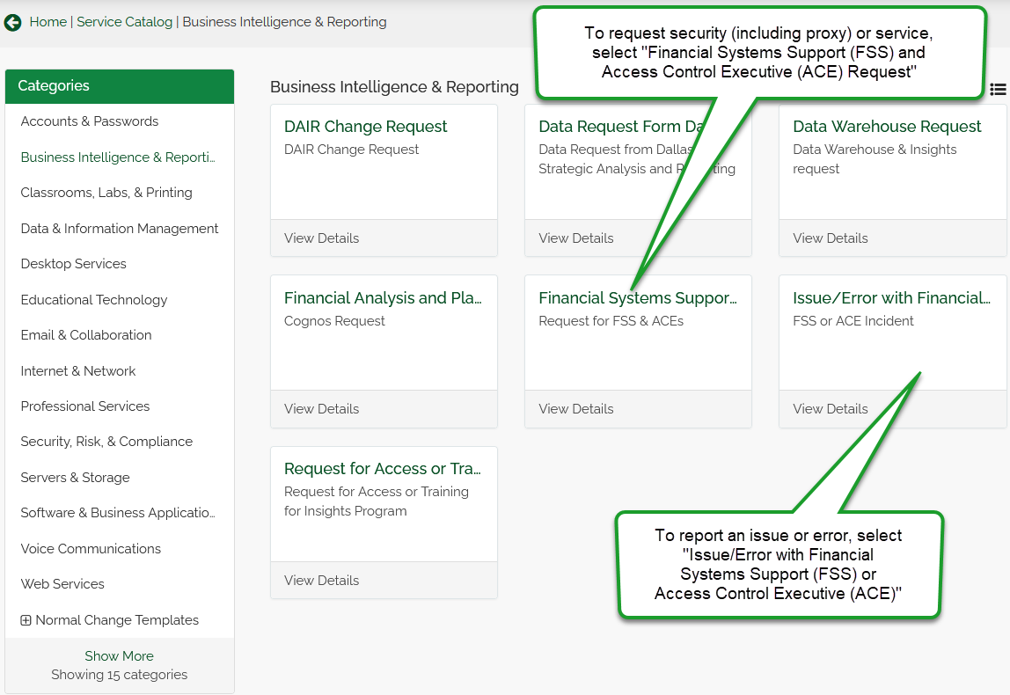

Security and Service Requests
Security requests are used for requests to add, modify, or remove security (including proxy) in EIS Financials environments (FSPD, FSQA, FSCP, etc.), Oracle/Golden, USAS, Perceptive Content, and Cognos.
To open a security request:
- Access Service Now (http://web3.unt.edu/helpdesk/service). Log in with your EUID and password
- Select “Business Intelligence & Reporting” tile from the Self Service page.
- Select “Financial Systems Support (FSS) and Access Control Executive (ACE) Request” from the “Business Intelligence & Reporting” page).
- The request form will populate. Complete the form with information requested, including attaching any relevant training certificates, and specify which types of access you are requesting.

The form should be completed for the person for whom the security is requested, rather than that of the requestor when requesting for another person. Entering the EUID where requested will prompt a system search and then populate each of the demographic fields for you.

Type of Request options for security-related requests are add, modify, and revoke. There is an additional option for all other requests.

Options within the form are designated by ticking the box(es) of the types of assistance requested, populating additional fields on the form to request any additional information to coordinate with the request. Please be sure to include all information necessary to complete your request, including attaching applicable training certificates.

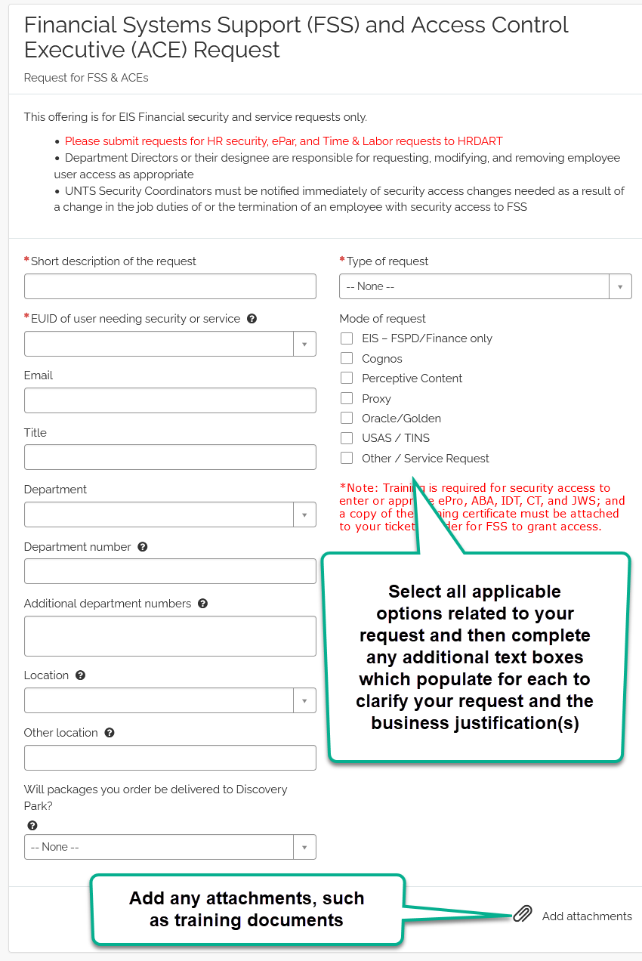

- Once all information is completed on the form and applicable attachments have been added, select “Order Now”
- Indicate for whom the request is, if not for yourself, then select “Checkout”.

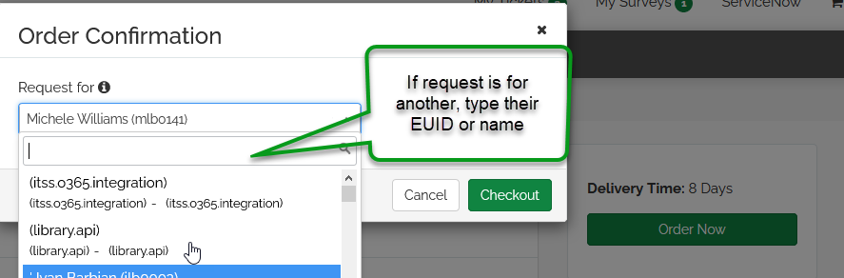

Issue/Error
Issue/error option is to report an incident needing assistance in EIS Financials environments (FSPD, FSQA, FSCP, etc.), Oracle/Golden, USAS, Perceptive Content, and Cognos.
To open an issue/error incident:
- Access Service Now (http://web3.unt.edu/helpdesk/service). Log in with your EUID and password
- Select “Business Intelligence & Reporting” tile from the Self Service page.
- Select “Issue/Error Financial Systems Support (FSS) and Access Control Executive (ACE)” request from the “Business Intelligence & Reporting” page).
- The Issue/Error form will populate. Complete the fields, providing as much information regarding the experienced issue or error, providing the environment in which the problem was encountered, any applicable business unit and document ID, and/or any steps already taken towards resolution. Use the “Add Attachments” paperclip to attach any relevant screenshots showing the problem encountered.
- Once all information is completed on the form and applicable attachments have been added, select “Order Now”
- Indicate for whom the request is, if not for yourself, then select “Checkout”.

